

Outreach GOV.UK Toolkit
Installation and User Guide

Toplevel Computing March 2015
Copyright ©2015 Toplevel Software Limited
Contents
Installing the GOV.UK Toolkit 3
Pre-requisites 3
Installation 3
Configuring a form to use the toolkit 5
General form settings 5
Form code 6
Declarations 6
Event handlers 7
User-defined functions 8
Utilising GOV.UK Toolkit features 9
Buttons 9
Help Text 11
Indented Headings 14
Field Validation 15
Summary 17
Summary set-up 17
Summary customisation 21

Installing the GOV.UK Toolkit

Pre-requisites
Before installing the GOV.UK Toolkit, you will need to have a copy of Outreach Server 12.0.2.8 or higher and Outreach e-Form Designer installed on your server, as well as all associated pre-requisites. For further details, please see the Outreach Server Installation and Configuration Guide.

Installation
- Copy all files from the Static directory of the GOV.UK Toolkit release into your Outreach Static directory (this should be located at C:\Program Files (x86)\OfficeForms\Server\Template\VirtualForm\Static).
- Copy OutreachGDSCustomStrings.htm from the Custom directory of the GOV.UK Toolkit release into your Outreach Custom directory (this should be located at C:\Program Files (x86)\OfficeForms\Server\Template\VirtualForm\Custom).
- Copy OutreachGDS_repo.ofcodemodule from the OFServerForms directory of the GOV.UK Toolkit release into your Outreach Active Forms directory (this should be located at C:\OFServerForms).
- Copy OutreachGDS.theme.xml from the Themes directory of the GOV.UK Toolkit release into your Outreach Themes directory (this should be located at C:\OFServerWorking\Themes).
- Start (or restart) your Outreach server:
- Press Windows Key + R to open the Run prompt. Type in services.msc and click OK.
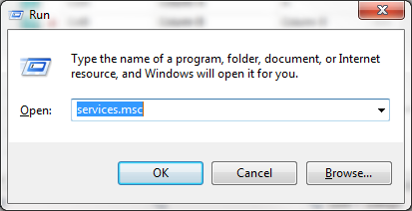
- In the Services window, scroll down until you find the OfficeForms Server service.
- Click the OfficeForms Server service and select either Start or Restart on the left sidebar.
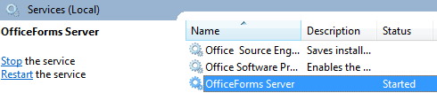

Configuring a form to use the toolkit

General form settings
- Open a new or existing form in Outreach e-Form Designer and go to Form Properties by double clicking the form icon in the top left of the field list.
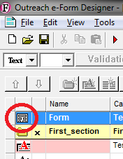
- In the General tab, under Appearance; Theme should be selected for Use. Change the Theme Name to OutreachGDS.
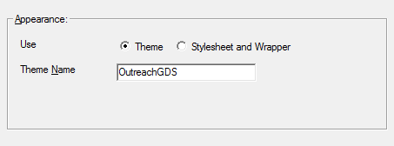

Form code
Open the Outreach Code Editor by navigating to Edit > Edit Form Code in the main menu. If you cannot find this option in the menu, go to Tools > Options and change the User Level to Developer.
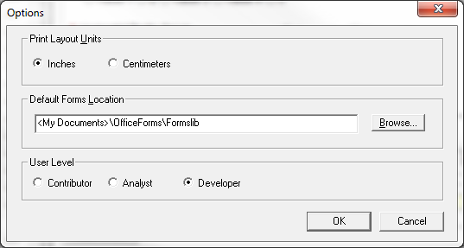

Declarations
Click on Declarations in the left sidebar:
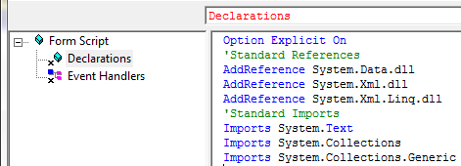

If the code below is not currently in Declarations, add it in:
Option Explicit On
'Standard References
AddReference System.Data.dll
AddReference System.Xml.dll
AddReference System.Xml.Linq.dll
'Standard Imports
Imports System.Text
Imports System.Collections
Imports System.Collections.Generic

Add the following lines to Declarations in the main window of the code editor:
Private Repo As Object
Dim ComponentCaptions As New Dictionary(Of String, String)

Event handlers
If they aren’t already displayed in your code editor, add the following event handlers:
- OnFirstLoadZCForm
- OnNewZCForm
- OnPresentSection
To do this, click the page icon above the main code window, choose Event Handler under Function Type and click OK.
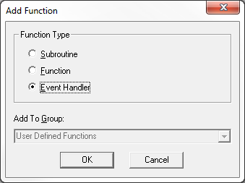
Choose the appropriate event handler and click OK, repeat until all event handlers have been added.
- Add the following code to OnFirstLoadZCForm:
If Not Outreach.CodeModuleLoad(Repo, "OutreachGDS_repo.ofcodemodule") Then
Form.ShowSystemError("Error", "Failed to load repo shared code module","","MEDIUM")
Form.EndModal("CANCEL")
Return
End If

ComponentCaptions = Repo.CaptionClone()
Repo.Summary("CAPTURE", ComponentCaptions)

- Add the following line to OnNewZCForm:
Repo.Init()

- Add the following line to OnPresentSection:
Repo.StepIndicator()

User-defined functions
Click the page icon above the main code window, choose Subroutine under Function Type and click OK.
This will create a new subroutine called NewSub1 (or similar). Above the main code window, you will see the subroutine name.
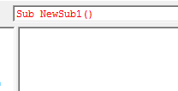
Change it to the following:
Sub Summary(action as String, Optional gotoSection as String = "")
In the main code window, add the following code:
If action = "EDIT" Then
Repo.Summary("EDIT", ComponentCaptions)
Else If action = "GOTO" Then
Form.CustomTokenSet("Summary", "")
Form.SectionSetNext(gotoSection)
End If

Utilising GOV.UK Toolkit features

Buttons
GDS Outreach forms can have three button types:
- Primary call-to-action
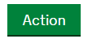
- Secondary actions
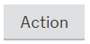
- Secondary toolbar & table actions
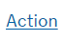
By default, a form configured to use the GOV.UK Toolkit will have a Continue button (equivalent to the Next button in default Outreach forms), Exit button and Back button (if there is a previous section to go back to) on the bottom toolbar.
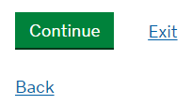
Additional buttons can be added to the toolbar, but it is the form designer’s responsibility to organise the order and layout of the toolbar through form code.
Each section should have a single primary call-to-action button. By default, this will be the Continue button shown above. However, the form designer can create their own primary call-to-action button by doing the following:
- Create a button element by adding a new field, navigating to the Field Data Properties and clicking the button icon in the General tab.
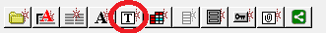
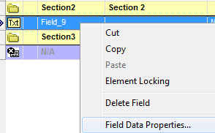
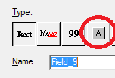
- Change the name of an existing or new button element, ensuring it ends with the suffix __pca.
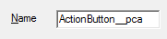
If creating a custom primary call-to-action button, it is recommended that the form designer hides the Continue button using the NavButtonShow command (see the Outreach Code Editor help for more information).
If a custom button does not have the __pca suffix, it will be styled as a secondary action button (or a secondary toolbar action button if Display on Toolbar is selected for the button).
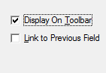

Similarly, a link button can be created by following the above steps, but adding the __link suffix instead of the __pca suffix.

Help Text
By default, fields with help text will have a help icon to the right, which opens a pop-up with the help text when clicked.
In order to utilise GDS-style help, a specific prefix needs to be added to the start of the help text. The available prefixes are as follows:

- Micro text (__micro:) – Available for both standard captions and caption over field.
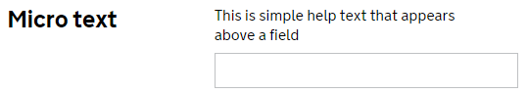
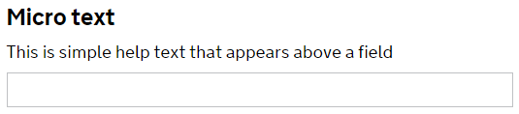

- Indented micro text (__indmicro:) – Available only for captions over field.
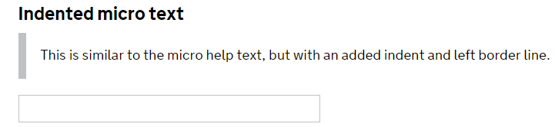
- Captioned dropdown (__drop:) – Available only for captions over field.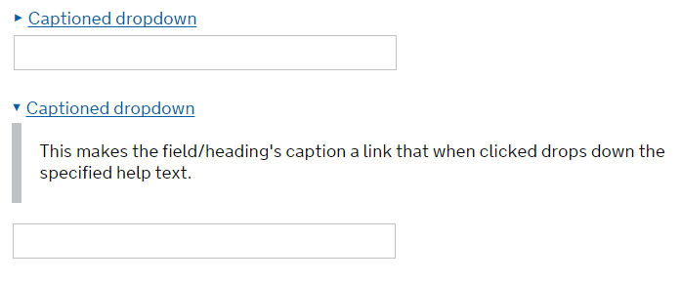

- Help dropdown (__help:) – Available only for captions over field. By default this will have the prompt text “Help”. This can be customised to have any prompt text by using a “||” separator in the __help tag:

__help: Help prompt||help text
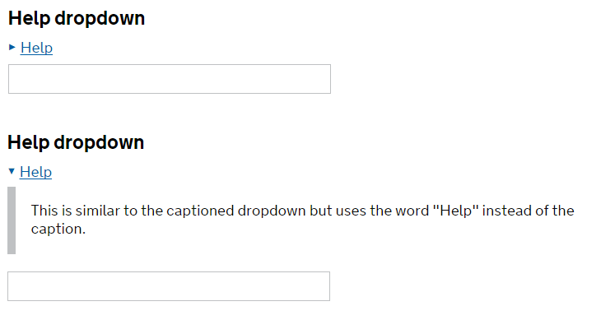
- Guidance text (__guidance:) – Available only for captions over field.
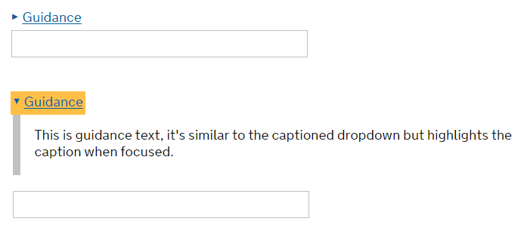
To add GDS-style help to a field, open its Field Data Properties and navigate to the Help and Captions tab. Choose one of the prefixes from above and add it to the beginning of your field’s help text. Note that if you have a field with a Standard Caption Layout and you add a prefix that is not compatible, the help text will not be displayed on the form. If there is no prefix, or Help Is URL is checked, the default Outreach help icon will be used.

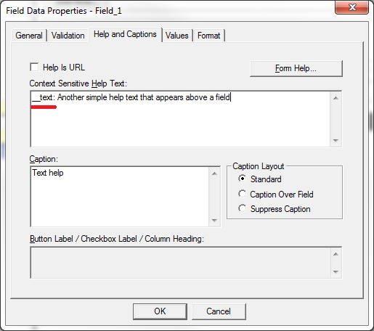

Indented Headings
Some GDS forms require content to stand out using indentation. In order to indent content, add a heading above all the fields and captions you wish to indent.
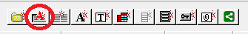
Then modify the name of the heading, ensuring it ends with the suffix __ind.
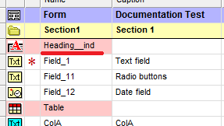
All fields and captions under that heading will now be indented.
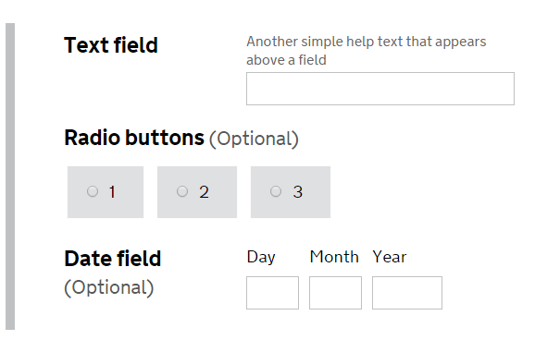

Field Validation
Field errors for a particular section are summarised at the top of the page. Each field error is clickable and will move focus to the field which requires attention. If a mandatory field has not been filled in, the default error text is “This is a required field and must be completed.”
This default text can be replaced with a reference to the specific field using a __mand: tag in the help text. This can be used alongside any of the other help text tags, the text of the __mand: tag will not show up in the help text, it will only be used for the mandatory field message.
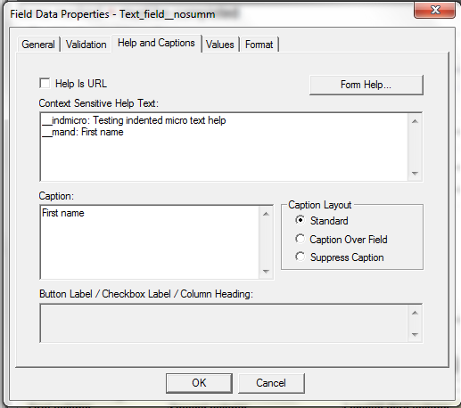
The above tag “__mand: First name” will result in the following error message if the field isn’t filled in:
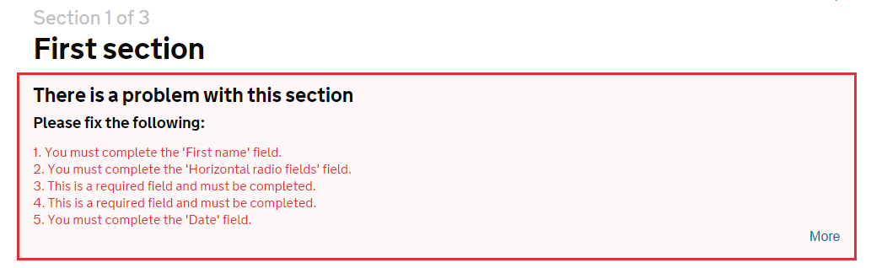

This error will also appear around the field in question:
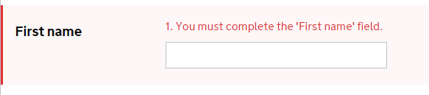

Summary

Summary set-up
The summary feature auto-generates a structured summary of the entire form’s fields and tables.
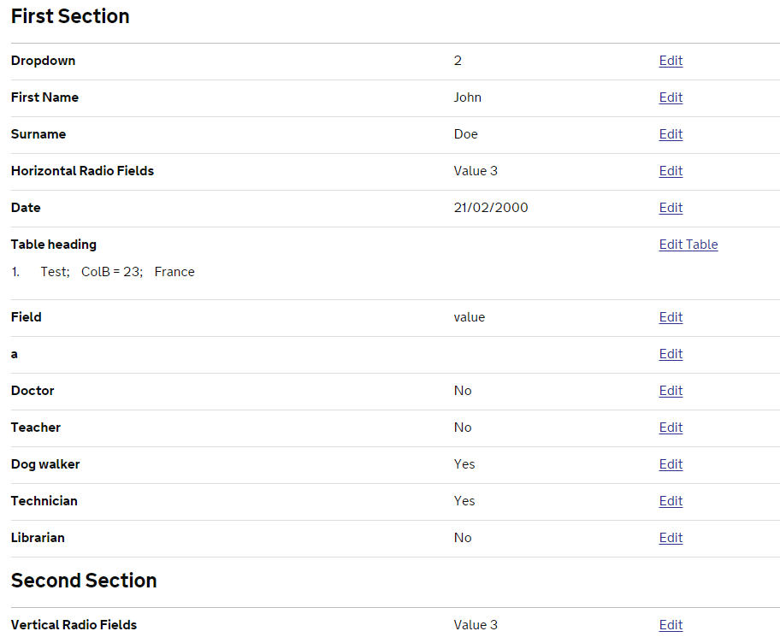
To use the summary feature, carry out the following steps:
- Create a summary section
Create a new section for the summary and give it a name (other than Summary). In our example, we have named it Summary_section.
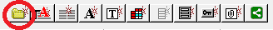
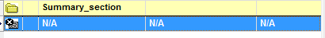
- Create a summary heading and caption
- Add a heading named Summary_element and under that heading, add a caption named Summaryelement.
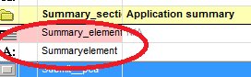

- Update the OnPresentSection event handler
In the Outreach Code Editor, navigate to the OnPresentSection event handler that was added during the configuration of the form for use with the GOV.UK Toolkit. Add the following code:
Select sName
Case "Summary_section"
Repo.Summary("INIT", ComponentCaptions)
Repo.OutputSummaryHTML()
End Select
Replace Summary_section with the name of the section you used in step 1.

- Add and set the OnCustomButton event handler
Instructions for adding event handlers can be found in the first part of this guide, Configuring a form to use the toolkit. Once the OnCustomButton event handler has been added, insert the following line:

If sName = "Summaryactionlink" Then Summary("EDIT")

- Update form tables to work with Summary
In order for table data to be displayed in the summary, an extra Summary column has to be added to each table in the form.
- For each table, click on the bottom row of the table element and click the New Table Column icon.
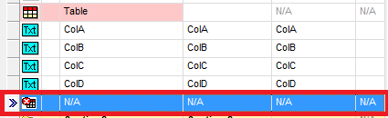
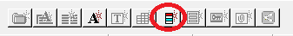
- Change the name of the new column to Summary and double click it to open the Field Data Properties dialog. Tick all three boxes under Hide Column On in the General tab. Note: the column must be named Summary for the table data to appear in the Summary section.
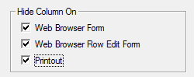
Repeat the above two steps for every table that you wish to display in the Summary section.

- Add Save & Back To Summary button
The summary section also includes an edit option next to each field and table in the summary. Clicking these will take you to the relevant section, replacing the Continue button with a Save & Back To Summary button. This replacement button needs to be added into the form.
Add a new button (add new field and change type to button) and change the name to Backtosummary. Note: The button must be named Backtosummary for correct functionality. Open the Field Data Properties and navigate to the Values tab. Click Add…, select Call BASIC Function and click OK. Enter the following code next to Function Name:
Summary("GOTO","Summary_section")
Replace Summary_section with the name of the section you chose in step 1 and click OK. Tick Display On Toolbar under the Format tab.
Change the Backtosummary button’s label to Save & Back To Summary, or any text that would be considered appropriate for the back to summary button.

Summary customisation
By default, the Summary feature will display all fields and table columns that are both enabled and visible. In some cases, you may wish to exclude some of these enabled and visible fields or columns from the summary. In order to do this, simply change the relevant item’s name to end with the suffix __nosumm.
That item will now never show in the summary, even if it’s visible and enabled.
Similarly, if you have a hidden or disabled field or column that you wish to display in the summary, change the relevant item’s name to end with the suffix __showsumm.

Summary template
For full customisation of the summary (e.g. re-ordering items, re-grouping items and adding custom constructed items) you can use a summary template. This is an XML file that specifies the structure of the summary.

Declaration and summary tag
The summary template must start with an xml declaration, followed by the summary start tag:
<?xml version="1.0" encoding="UTF-8"?>
<summary>

Items
Once you have the declaration and summary tag, you can add items to the template. There are two types of item: section and component.

Section Items
The section items will display as headings on the summary table. The very first item in the summary template must be a section item.
<item type="section">Section_start</item>
This should only contain the name of the section specified in the Outreach designer. The section label will be used as a heading in the summary table.
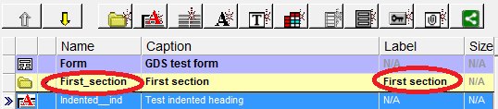
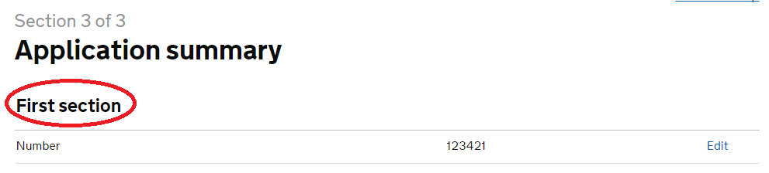
Component Items
Component items are the non-heading rows in the summary table. All items of type component must have a name and value tag specified. They can also optionally have a linkedfield tag (apart from tables).
The name tag corresponds to the left column, while the value tag corresponds to the right column. The linkedfield tag ties the row in to a particular field on the form.
<item type="component">
<name source="field">Street_name</name>
<value source="field">Street_name</value>
<linkedfield>Street_name</linkedfield>
</item>

The name and value tags can retrieve data from three different sources: field, static or custom.
- The field source uses the field name from the Outreach designer. Name tags that use the field source will display the field caption. Value tags that use the field source will display the value entered into the field by the end-user.
<name source="field">Street_name</name>
<value source="field">Street_name</value>
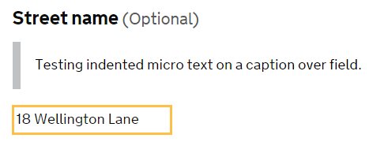
- The static source uses the text inside the name / value tag.
<name source="static">Testing static</name>
<value source="static">Test</value>
- The custom source uses a dictionary of custom items which are set up in the solution. This might be used when, for example, you want to combine the first and last names into a single row.
<name source="static">Applicant full name</name>
<value source="custom">Full_name</value>
In the solution, an example implementation would then be as follows:
Dim customItems As New Dictionary(Of String, String)
Dim firstName As String = Form.FieldGetData("First_name")
Dim lastName As String = Form.FieldGetData("Last_name")
customItems.Add("Full_name", String.Format("{0} {1}", firstName, lastName))

You would then pass the customItems Dictionary into the set-up function for the summary with a template (described at the end of this chapter).

The linkedfield tag simply contains the name of the field with which you wish to link the current item. When the user clicks the Edit link next to the item in the summary table, they will be taken to the section which contains the field in the linkedfield tag and move focus to it.
The linkedfield tag is optional, but if it is not defined for an item, there will be no Edit link for that item in the summary table (except for tables, which use the table name defined in the value tag.
<linkedfield>Street_name</linkedfield>
Once you have added all your items to the template, add a closing summary tag.
</summary>
Save the template as an XML file and place it in your Outreach server’s Custom directory (e.g. C:\Program Files (x86)\OfficeForms\Server\Template\VirtualForm\Custom).

Summary set-up with a template
If you wish to use a summary template, you will need to modify the code added to the OnPresentSection event in step 3 of the summary set-up.
Replace the code below:
Select sName
Case "Summary_section"
Repo.Summary("INIT", ComponentCaptions)
Repo.OutputSummaryHTML()
End Select
With the following code:
Select sName
Case "Summary_section"
Repo.InitSummaryFromTemplate(“Template_name.xml”, ComponentCaptions)
Repo.OutputSummaryHTML()
End Select

Where “Template_name.xml” is the filename of your summary template, with the .xml extension.

If you also used items with a custom source (i.e. name and value tags with source attribute set to custom), you will instead use the following code:

Select sName
Case "Summary_section"
Repo.InitSummaryFromTemplateWithCustomData(“Template_name.xml”, ComponentCaptions, customItems)
Repo.OutputSummaryHTML()
End Select
Where customItems is the Dictionary populated with your custom values.

